Chapter 3 p.61

Chinese targeting of US sectors

Chinese state-sponsored threat actors were broadly interested in US military capabilities and its policymaking during this reporting period

Pie chart showing percentages of the Chinese targeting of US sectors. It shows A. Défense: 22%, B. IT: 16%, C. Communications: 13%, D. Government: 12%, E. NGOs and Think tanks: 10%, F. Education: 6%, G. Energy: 5% H. Manufacturing: 3%, I. Transportation: 3%, J. Water: 3%, and K. Other: 7%.

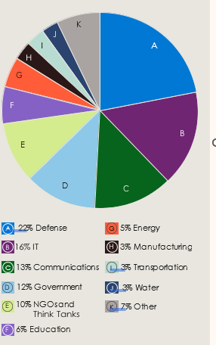

Source: Microsoft Threat Intelligence